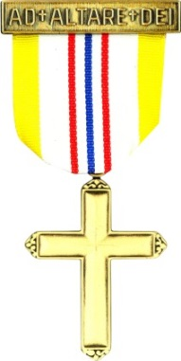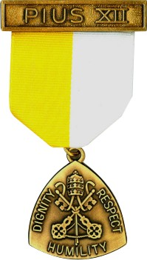
Archdiocese of Cincinnati
Catholic Committee on Scouting
2022 Ad Altare Dei & Pope Pius XII
Religious Emblem Boards of Review

Ad Altare Dei & Pope Pius XII Boards of Review will be conducted in the Cincinnati area during the week of January 8-14, 2022 by representatives of the Archdiocesan Catholic Committee on Scouting, at the following locations within the Archdiocese of Cincinnati and Dan Beard Council. A Board of Review must be conducted prior to awarding a Scout or Venture Crew member with the Ad Altare Dei or Pope Pius XII Religious Emblem. All participants MUST PRE-REGISTER for a date and location.

Saturday, Jan. 8th –Scout Achievement Center- 10078 Reading Rd. 45241
Monday, Jan.10th-St Ignatius- Loyola Hall- 5222 N Bend Rd-45247
Wednesday, Jan. 12th- Immaculate Heart of Mary- Heritage Hall-7800 Beechmont Ave. 45255
Friday, Jan. 14th- St Susanna- Meyer Center-500 Reading Rd 45040

Northern area Boards of Review by request – contact Harry Heaton at harryheaton@me.com

An “Intent to Begin” form or email MUST be sent as you begin your emblems program so we can determine the number of Boards that will be needed.

Note: All Boards must be completed and paperwork received in the Archdiocese office by January 21, 2022.

Scouts are required to wear the appropriate BSA uniform of their troop or crew and bring their emblem book with all required signatures.

To pre-register or for more information about the Religious Emblems Boards of Review, please contact one of the Catholic Committee on Scouting representatives listed below:

Tom Wiles or Harry Heaton-Northern Area
Tjwiles83@gmail.com harryheaton@me.com

These and other Religious Emblems, along with the Adult Religious Awards, will be presented by our Scout Chaplain, at the Cathedral Basilica of St. Peter in Chains, in downtown Cincinnati, on Sunday, February 27,2022 at 2:00 p.m.

